This ActiveX DLL has been developed using Microsoft Visual Basic 6 and requires SP3 to be installed.

This is the first version and I would welcome any feedback or criticisms. Please direct all correspondence to RobertBrown@TheContrastCompany.co.uk.

The DLL contains about 350 quotations. A new version that I am currently testing will contain over 10,000 quotations available in different categories. I am also developing a help file to complement the ActiveX DLL.

The source code is available on request.

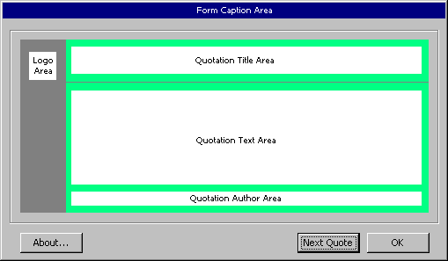

Available Properties

Property Name | Description
AuthorFontBold | Set/Returns the Font Bold for Quotation Author area.
AuthorFontName | Set/Returns the Font Name for Quotation Author area.
AuthorFontSize | Set/Returns the Font Size for Quotation Author area.
AuthorForecolor | Set/Returns the Font Forecolor for Quotation Author area.
FormBackcolor | Set/Returns the Quotation Form and Frame Backcolor.
FormCaption | Set/Returns the Caption of the Quotation Form.
Left | Set/Returns the Left position of the Quotation Form.

Property Name | Description
QuotationBackcolor | Set/Returns the Backcolor of the Quotation Text Area.
QuotationLogo | Set/Returns the picture for the Quotation Logo Area.
QuotationTitle | Set/Returns the Caption of the Quotation Text area.
QuoteFontBold | Set/Returns the Font Bold for Quotation Text area.
QuoteFontName | Set/Returns the Font Name for Quotation Text area.
QuoteFontSize | Set/Returns the Font Size for Quotation Text area.
QuoteForecolor | Set/Returns the Font Forecolor for Quotation Text area.
ShowCentre | Centres the Quotation Form on the screen.
ShowNextQuoteButton | Set/Returns the visibility of the Show Next Quote Button.
ShowOnTop | Show the Quotation form on-top of all others.
TitleFontBold | Set/Returns the Font Bold for Title Text area.
TitleFontName | Set/Returns the Font Name for Title Text area.
TitleFontSize | Set/Returns the Font Size for Title Text area.
TitleForecolor | Set/Returns the Font Forecolor for Title Text area.
Top | Set/Returns the Top position of the Quotation Form.

Available Methods

Method Name | Description
ShowQuotation | Displays the Quotation Form and selects a Quotation randomly

